***AIDS MICROPROCESSOR LAB S21 BATCH (2023-24)***

***Experiment 11 Title: Assembly language programming to compute the factorial of a positive integer ‘n’ using procedure.***

***Name of student: Meet Raut Class Roll Number: 2201084***

***Date of Performance: 01/04/2024***

***Batch: S2-1 Timing: 3:00-5:00 Date of Submission: -01/04/2024***

***Assembly language code***

*DATA_SEG SEGMENT*

*NUM DB 07 #Input positive integer*

*ANS DW 00 #Variable to store the factorial result*

*DATA_SEG ENDS*

*CODE_SEG SEGMENT*

*ASSUME CS:CODE_SEG, DS:DATA_SEG, ES:DATA_SEG*

*START:*

*MOV AX, DATA_SEG #Initialize DS and ES with the address*

*MOV DS, AX of DATA_SEG*

*MOV ES, AX*

*MOV AH, 00 # Clear AH register*

*MOV AL, NUM # Load the positive integer into AL*

*MOV CH, 00 #Clear CH register*

*MOV CL, NUM #Load the positive integer into CL*

*DEC CX #Decrement CX for the initial computation*

*CALL FACTORIAL #Call the factorial procedure*

*FACTORIAL PROC NEAR*

*CMP CX, 01 #Check if CX is 1*

*JNE CALC*

*MOV ANS, AX # Store the result when CX is 1*

*RET*

*CALC: MUL CX #Multiply current value with CX*

*DEC CX #Decrement CX*

*CALL FACTORIAL #Recursive call to the factorial procedure*

*FACTORIAL ENDP*

*MOV AH,4CH*

*INT 21H*

*CODE_SEG ENDS*

*END START*

*Result:*

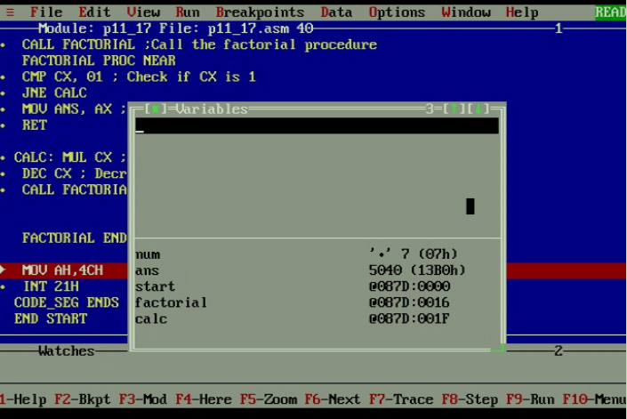

*CONCLUSION: LO 2, LO 3 mapped.*

***---------------------------------*****************************-----------------------------------***